A Facebook event will be put up and advertised over next week (so just in the lead up to O-week which is the week after.

This is what the Facebook event cover photo looks like at the moment:

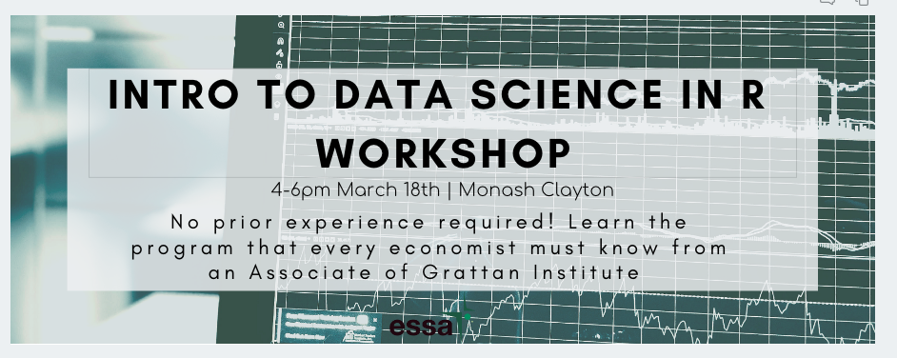

It will be accompanied by the following description:

ESSA is proud to announce that William Mackey from Grattan Institute will be running a workshop on analysing and visualizing data using R. No prior experience is required, only an open mind and can-do attitude. Come along to have one of the fastest-growing programming skills in the economics world demystified and simplified.

Whether you’re a first year who’s just getting a grip on economic theory or a third year looking for skills to add to your CV before applying to grad-roles, you will learn how to read, manipulate and visualise data in R.

AGENDA

The workshop will cover:

* Why we should use R for reproducibility and consistency
* Installing and running R
* Best workflow practices
* Reading and manipulating real-world data
* Performing exploratory visual analysis
* Presenting data in charts, maps, and web apps

DETAILS

Date: Mon 18th March 2019

Time: 4-6pm

Location: Monash Clayton TBC

So you minimize how much trouble you run into during the workshop, we ask that you attempt to download and install R beforehand using the following steps:

If you run into trouble, don’t fret, and message the ESSA page for assistance and we’ll get you set up.

Posts like this will be put up on the ESSA Facebook page:

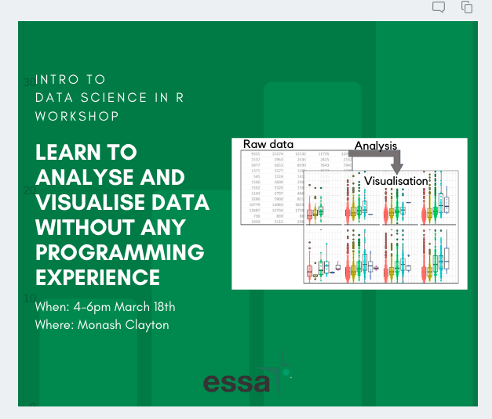

Once uni starts we’ll be printing out and putting up flyers that look like this:

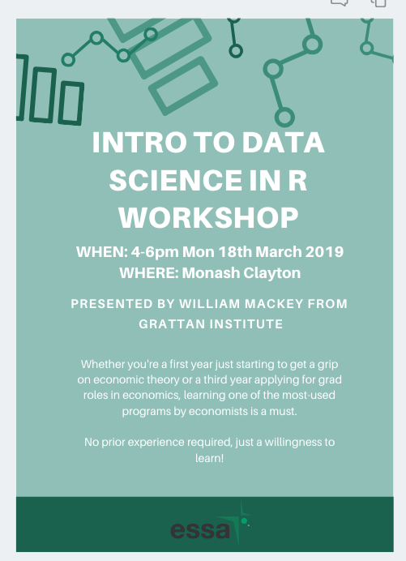

**Edit for the poster:**

From: …learning one of the most-used programs by economists is a must.

To: …learning one of the fastest-growing tools for economists is a must.

Queries:

* If you have cool graphics feel free to send them over when you can and we can add them to the materials and update the materials we currently have.
* If you have the workshop planned out a little more we can also update the agenda for the event so people can decide if they want to come to the first or second half. We can always update the event online so no stress if you don’t have it planned out yet. We will still be able to announce it and put it up just to start getting the word out there.
* In regards to the event description, if you would be able to outline how to download and install that would be great. I can try and simplify the instructions and also include it in the poster so people who don’t see the event online but see it around uni will also have R installed. If it won’t fit we’ll simply ask them to look out for the Facebook event for further details. I also wasn’t sure if you wanted your email publicized on the Facebook event so I’ve requested that people having trouble message us first and we can put them into contact with you in direct private message.
* If you have any feedback or other ideas, please let me know.

Thanks again, Will!

Thao-Mi